
K J Somaiya Institute of Technology
An Autonomous Institute Permanently Affiliated to the University of Mumbai DEPARTMENT OF INFORMATION TECHNOLOGY
Name of Student : Aditya Bali
Roll No : B - 71
Batch : SB4
EXPERIMENT 5
Aim:
To implement Singly Linked List
Objective:
● To understand the concept and structure of a Singly Linked List in Data Structures and Algorithms (DSA).
● To learn how nodes are created and linked dynamically using pointers. ● To implement basic operations such as insertion, deletion, traversal, and searching in a singly linked list.
● To understand how a singly linked list differs from an array in terms of memory allocation and data organization.
● To develop a program that demonstrates the working of a singly linked list using assembly or a suitable programming language.
Software Used:
● Turbo C / Turbo C++
● DOSBox
Theory :
A Singly Linked List is a linear data structure in which elements, called nodes, are connected using pointers. Each node consists of two parts: a data field, which stores the actual value, and a next pointer, which stores the address of the next node in the list. The last node contains a NULL pointer, indicating the end of the list.
Unlike arrays, linked lists do not require contiguous memory locations. Memory is allocated dynamically whenever a new node is created, making linked lists useful when the size of the data structure changes frequently.
The first node of the list is accessed through a pointer called HEAD. The basic operations performed on a singly linked list include insertion, deletion, traversal, and searching. Insertion adds a new node to the list, deletion removes an existing node, traversal visits each node sequentially, and searching finds a particular element.
A singly linked list allows efficient insertion and deletion when the required position or node is already known. However, it supports only forward traversal because each node stores the address of the next node and not the previous node.
Program :
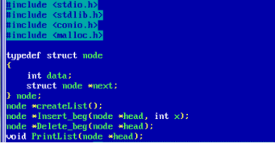
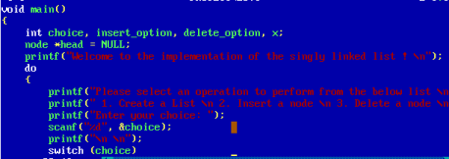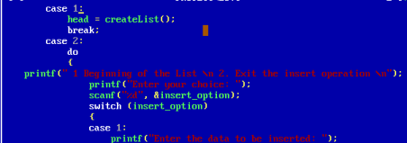
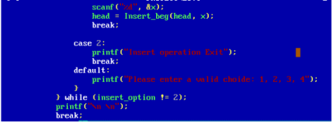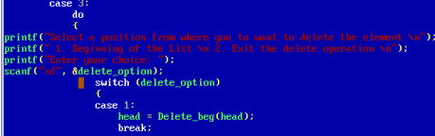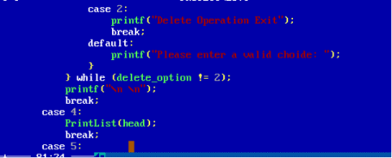
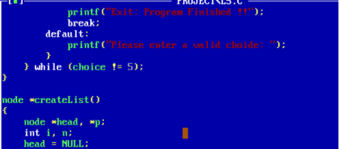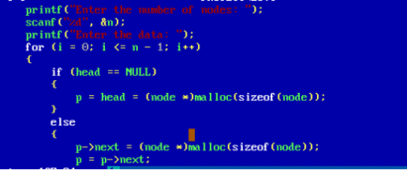
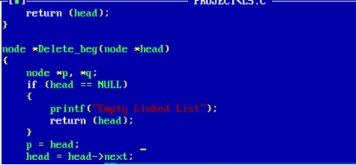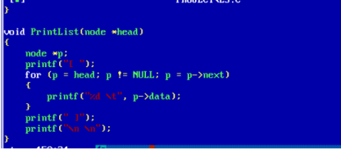Output :
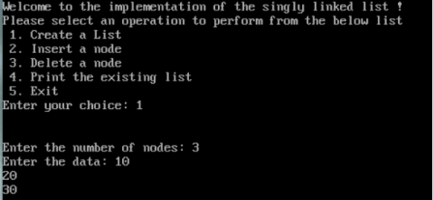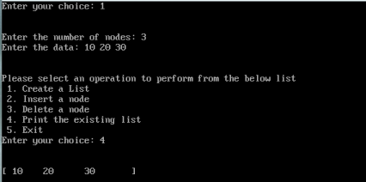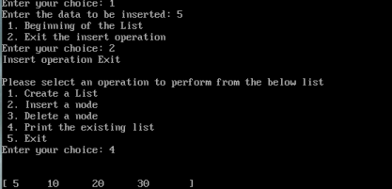
Outcome :
The singly linked list data structure was studied and implemented successfully. The structure of nodes, the use of pointers to connect nodes, and the basic operations of insertion, deletion, and traversal were understood. The practical demonstrated how linked lists store and manage data dynamically.
Conclusion :
Thus, the implementation of a Singly Linked List was studied successfully. The practical helped in understanding dynamic memory organization, pointer-based connections between nodes, and fundamental linked-list operations. It also provided a clear understanding of how linked lists can be used to manage data efficiently in Data Structures and Algorithms.

